COME ON OUT AND SUPPORT YOUR LOCAL CHARITIES!!!
Sunday | Monday | Tuesday | Wednesday | Thursday | Friday | Saturday
BINGO BINGO
61 Needham Street
Lindsay, Ontario
(705) 324-6463
www.lindsaybingo.com
FEBRUARY 2020
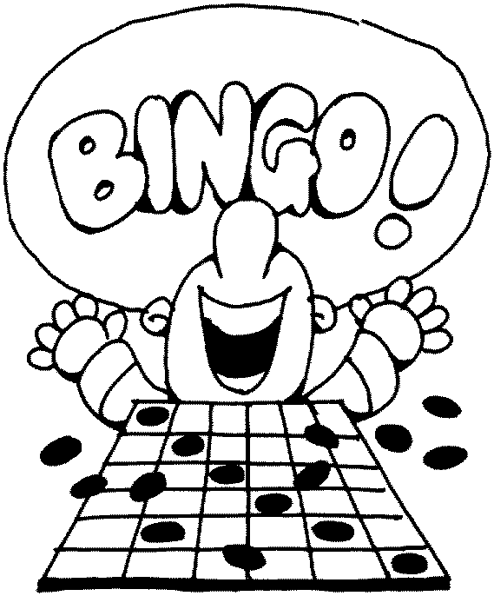
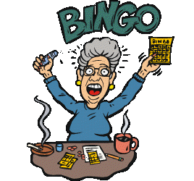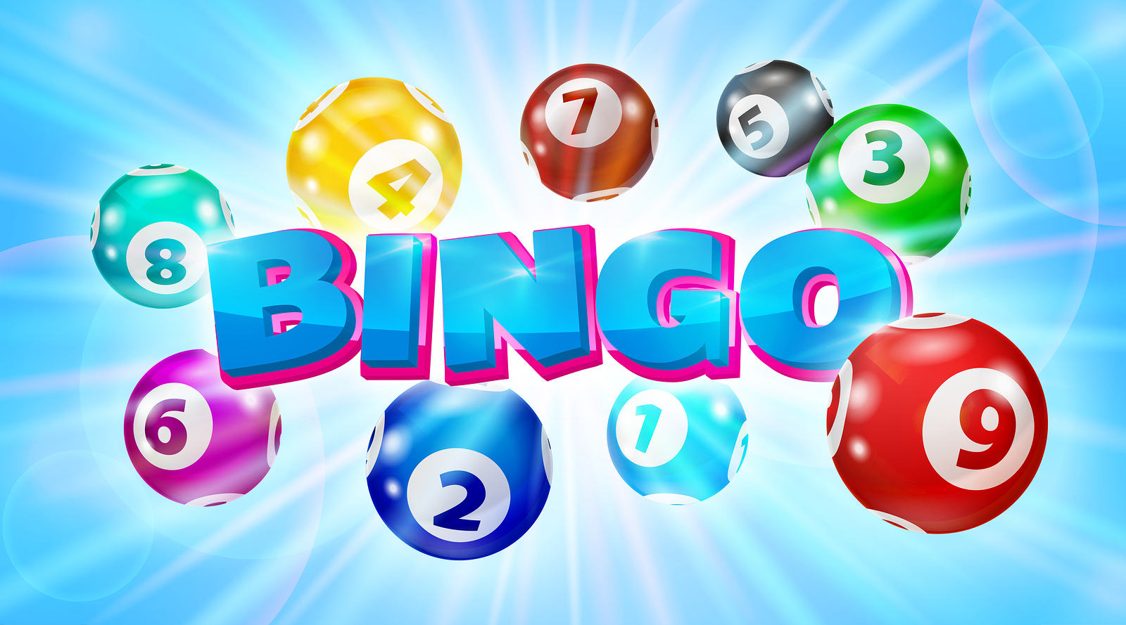

SUNDAY  12:30 & 9:45  $2.00 Strip  Bingo Cards  6:45  2  $500 GAMES  IN BOOK  Reg. Games  $100 / $200 | MONDAY  12:30  $2.00 Strip  Bingo Cards | TUESDAY    WOW!  All Day Long  Toonie Madness  All Day Long  $2.00 Strip  Bingo Cards | WEDNESDAY  12:30  $2.00 Strip  Bingo Cards | THURSDAY  WOW!  All Day Long  Twoonie Madness  All Day Long  $2.00 Strip  Bingo Cards | FRIDAY  12:30 & 9:45  $2.00 Strip  Bingo Cards  6:45  PLATINUM VERIFIER PKG.  FOR ONLY  $50.O0 | SATURDAY  12:30 & 9:45  $2.00 Strip  Bingo Cards  6:45  U-Pick-Um  MUST GO !  $1,000.00
TRI-COLOUR FINAL JACKPOT  FULL CARD  $2.00 for your chance to win an extra $500.00  MULTIPLE WINNERS SHARE | SUPER  PROGRESSIVE  In designated #’s  Maximum  $3,000.00 | SHUTTER  BOARD  5 Games for $10.00  1 Line or 4 Corners  In designated #’s Maximum  $1,000.00 | CUSTOMER APPRECIATION  COMPLIMENTARY BINGO  MON. FEB. 3rd  DOORS OPEN 9 AM  BINGO @ 10:30 AM |  | SPECTACULAR  SATURDAY’S  FEB. 08TH  7 - $500 PRIZES  $2,000 JACKPOT  REG. GAMES  $50 / $250  PROGRESSIVE GAMES  MIN. $500 | 
On behalf of Bingo Bingo Charities Association, Management & Staff, we would like to thank you for your continued support!.

