DECEMBER 2021

BINGO BINGO 61 NEEDHAM ST. LINDSAY, ONTARIO 705-324-6463 www.Lindsaybingo.com
Sunday |  | Monday |  |  |  | Tuesday |  | Wednesday |  |  | Thursday |  |  | Friday |  |  |  | Saturday
SUNDAY  12:30 & 9:45  $2.00 Strip  Bingo Cards |  |  | MONDAY  12:30  $2.00 Strip  Bingo Cards |  | TUESDAY    WOW!  All Day Long  $2.00 Strip  Bingo Cards |  |  |  | WEDNESDAY  12:30  $2.00 Strip  Bingo Cards |  |  | THURSDAY  WOW!  All Day Long  $2.00 Strip  Bingo Cards |  |  | FRIDAY  12:30 & 9:45  $2.00 Strip  Bingo Cards  6:45  PLATINUM VERIFIER PKG.  FOR ONLY  $50.O0 | SATURDAY  12:30 & 9:45  $2.00 Strip  Bingo Cards  6:45  UPIC  MUST  GO  $1000.00
TRI-COLOUR FINAL JACKPOT  FULL CARD  $2.00 for your chance to win an extra $500.00  MULTIPLE WINNERS SHARE | 12 DAYS OF CHRISTMAS GIVEAWAYS BEGINS DECEMBER 12 TO DECEMBER 23/21 |  |  | SHUTTER  BOARD  5 Games for $10.00  1 Line or 4 Corners  In designated #’s Maximum  $1000.00 |  |  | 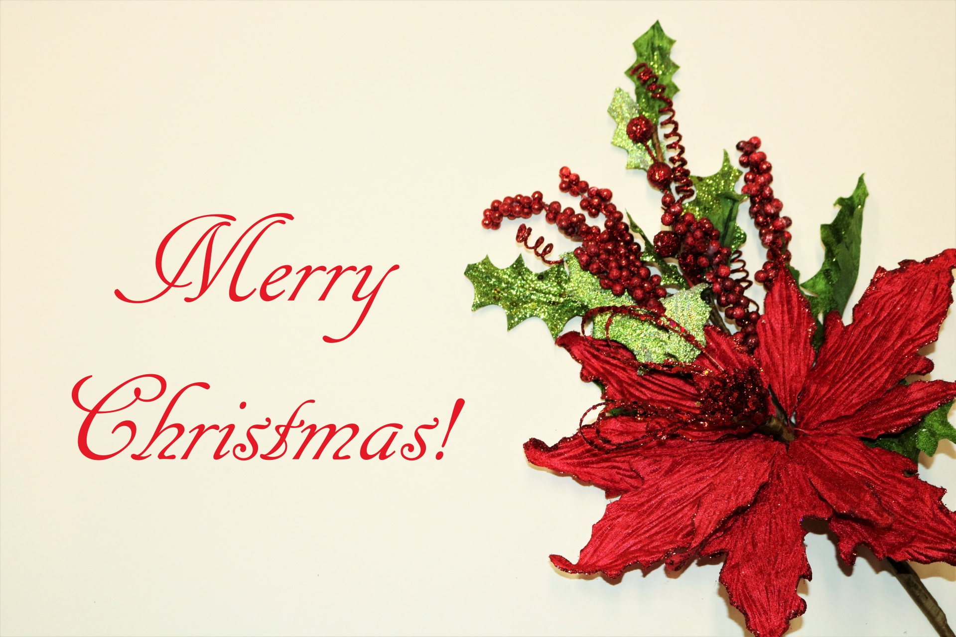 |  |  | SUPER  PROGRESSIVE  JACKPOT  In designated #s  MAXIMUM  $3000.00 |  |  | 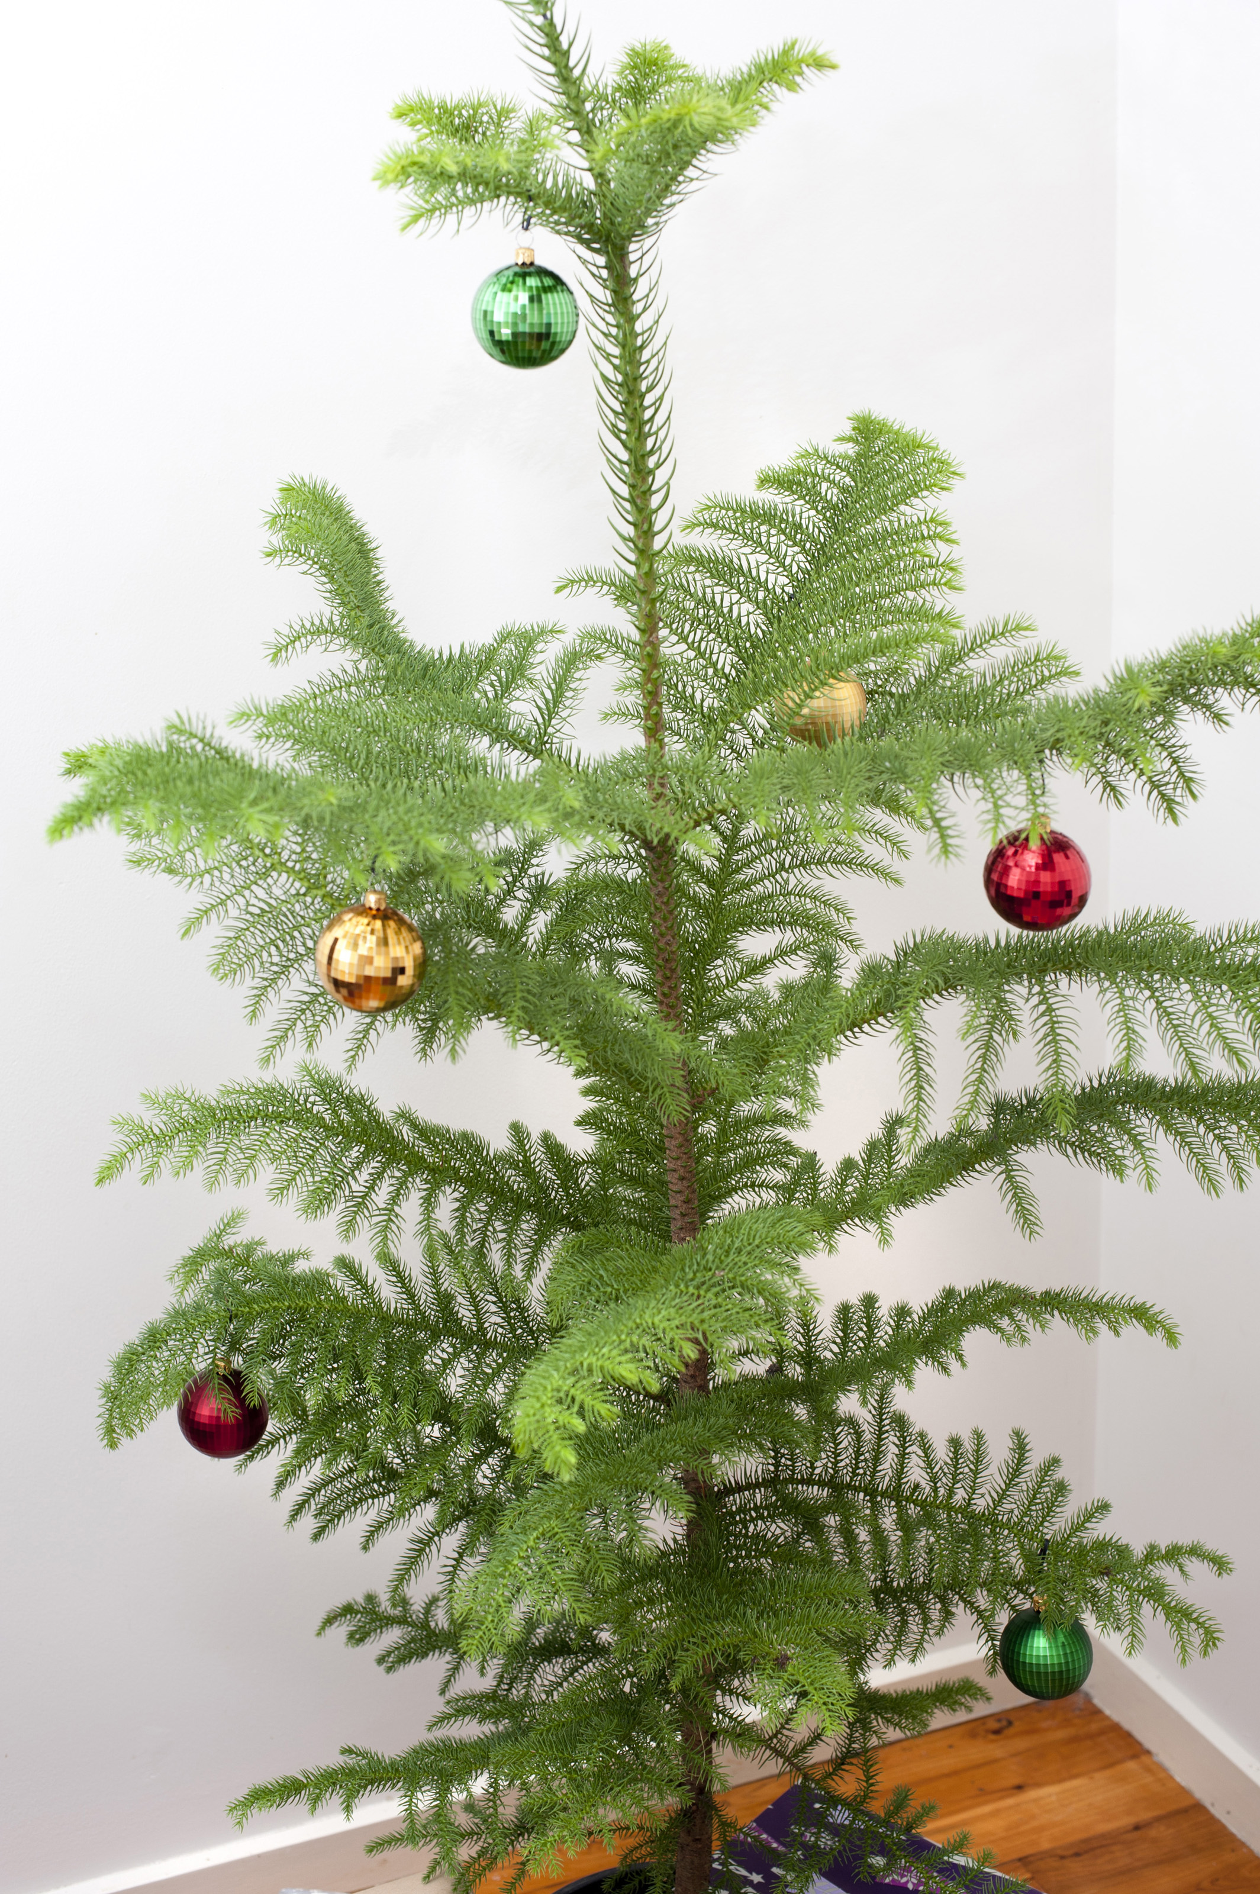 |  |  |  | NEW YEARS EVE  TICKET SALES BEGIN DECEMBER 6TH, 2021  $10.00 THIS INCLUDES DINNER, DOOR PRIZES AND $10.00 OFF YOUR PACK.  LIMITED NUMBER  AVAILABLE

