**RISING JACKPOT**

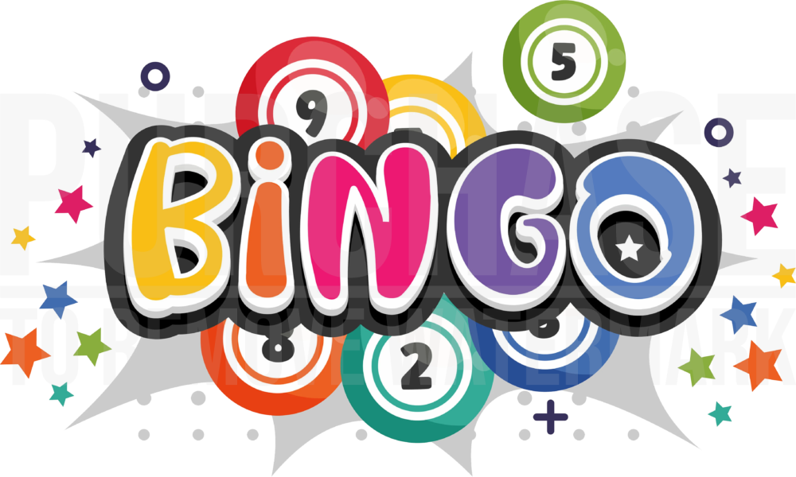

STARTING **JULY 20TH**

AT **EVERY SESSION**

WIN THE FINAL JACKPOT IN THE **DESIGNATED #**

TO WIN THE ADDITIONAL **PRIZE**

OUR RISING JACKPOT WILL

**INCREASE A #** EVERY **$1000.00**